Long-Term Media Equipment Reservation
Process for Talbott Springs ES

Directions: To request media equipment please follow the steps listed below.

- Refer to calendar spreadsheet for availability
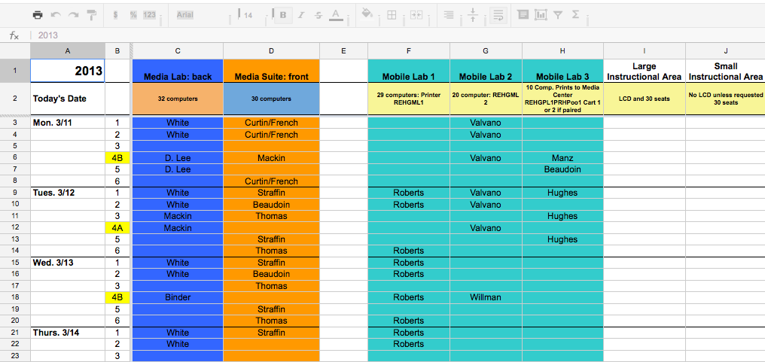

- Email Ruth Walker, lead technology teacher with:
  - Item requested
  - Date of request
  - Time of request

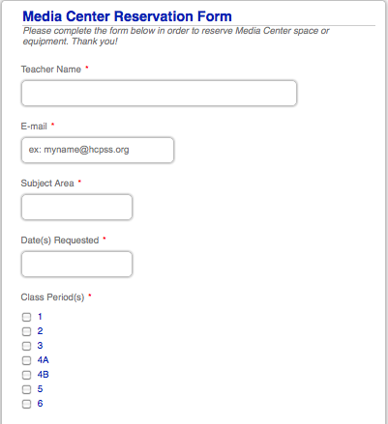

- After confirmation of availability from Ruth Walker, complete the following survey to receive your materials.

